Set 8 – Employee Performance Analysis
Dataset: Employee Performance
Question 1: Create a line chart to visualize the performance trend of employees over time. Label the axes and title the chart.
Answer
The dataset has no calendar-date field, so “time” is represented by Years of Service. Employees are ordered by years of service to show how performance changes as service lengthens.
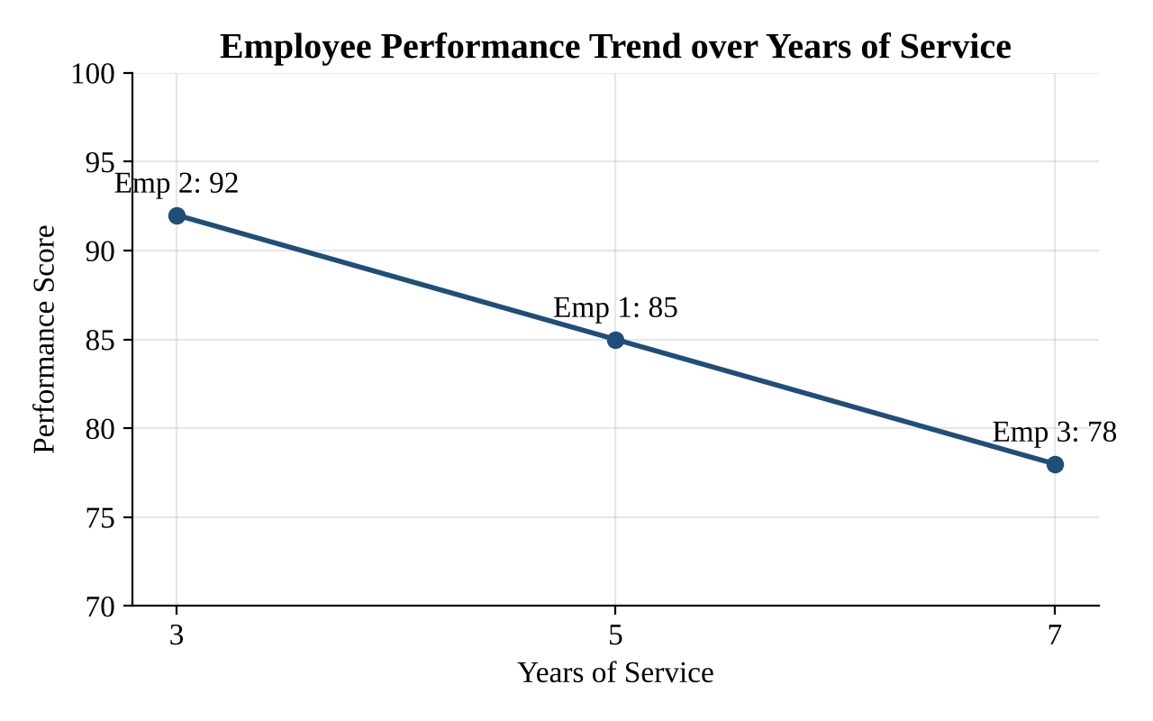
Figure 1: Line chart of performance score against years of service
Chart elements
- Title: Employee Performance Trend over Years of Service
- X-axis: Years of Service Y-axis: Performance Score
- Observation: Performance falls as years of service rise: 92 (3 yrs, HR) → 85 (5 yrs, Sales) → 78 (7 yrs, Marketing). With only three records this is a descriptive pattern, not a statistically reliable trend.
Tableau steps
- Drag Years of Service to Columns and Performance Score to Rows → Marks: Line; add Employee ID to Label.

Set 8 – Employee Performance Analysis
Dataset: Employee Performance
Question 2: Generate a bar chart showing the distribution of employees across different departments. Label the chart elements.
Answer
Each department currently has exactly one employee in the dataset.
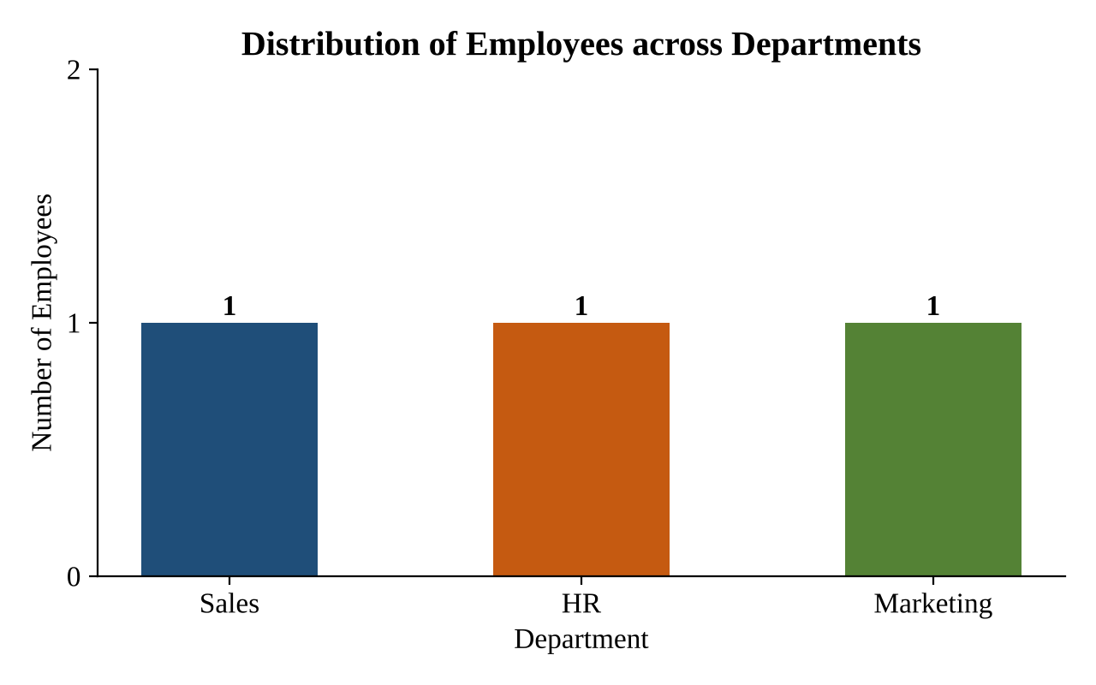
Figure 2: Bar chart of employees by department
Department distribution
Department | Number of Employees
Sales | 1
HR | 1
Marketing | 1
Total | 3

Chart elements
- Title: Distribution of Employees across Departments
- X-axis: Department Y-axis: Number of Employees
Tableau steps
- Drag Department to Columns and CNT(Employee ID) to Rows → Bars; add labels and axis titles.

Set 8 – Employee Performance Analysis
Dataset: Employee Performance
Question 3: Build a table to display the performance data for each employee. Label the table elements.
Answer
The table below lists the performance data of each employee, with each column labelled.
Employee ID | Department | Years of Service | Performance Score
1 | Sales | 5 | 85
2 | HR | 3 | 92
3 | Marketing | 7 | 78
Table 1: Employee performance data
Table elements
- Employee ID – unique identifier of the employee.
- Department – Sales, HR or Marketing.
- Years of Service – completed years with the company.
- Performance Score – performance rating of the employee.
Summary statistics
Measure | Years of Service | Performance Score
Minimum | 3 | 78
Maximum | 7 | 92
Average | 5 | 85

Tableau steps
- Drag the four fields into Rows, or use Measure Names / Measure Values → Show Me → Text Table.

Set 8 – Employee Performance Analysis
Dataset: Employee Performance
Question 4: Develop a Tableau dashboard combining the line chart, bar chart, and the table for interactive exploration of employee performance data.
Answer – Dashboard layout
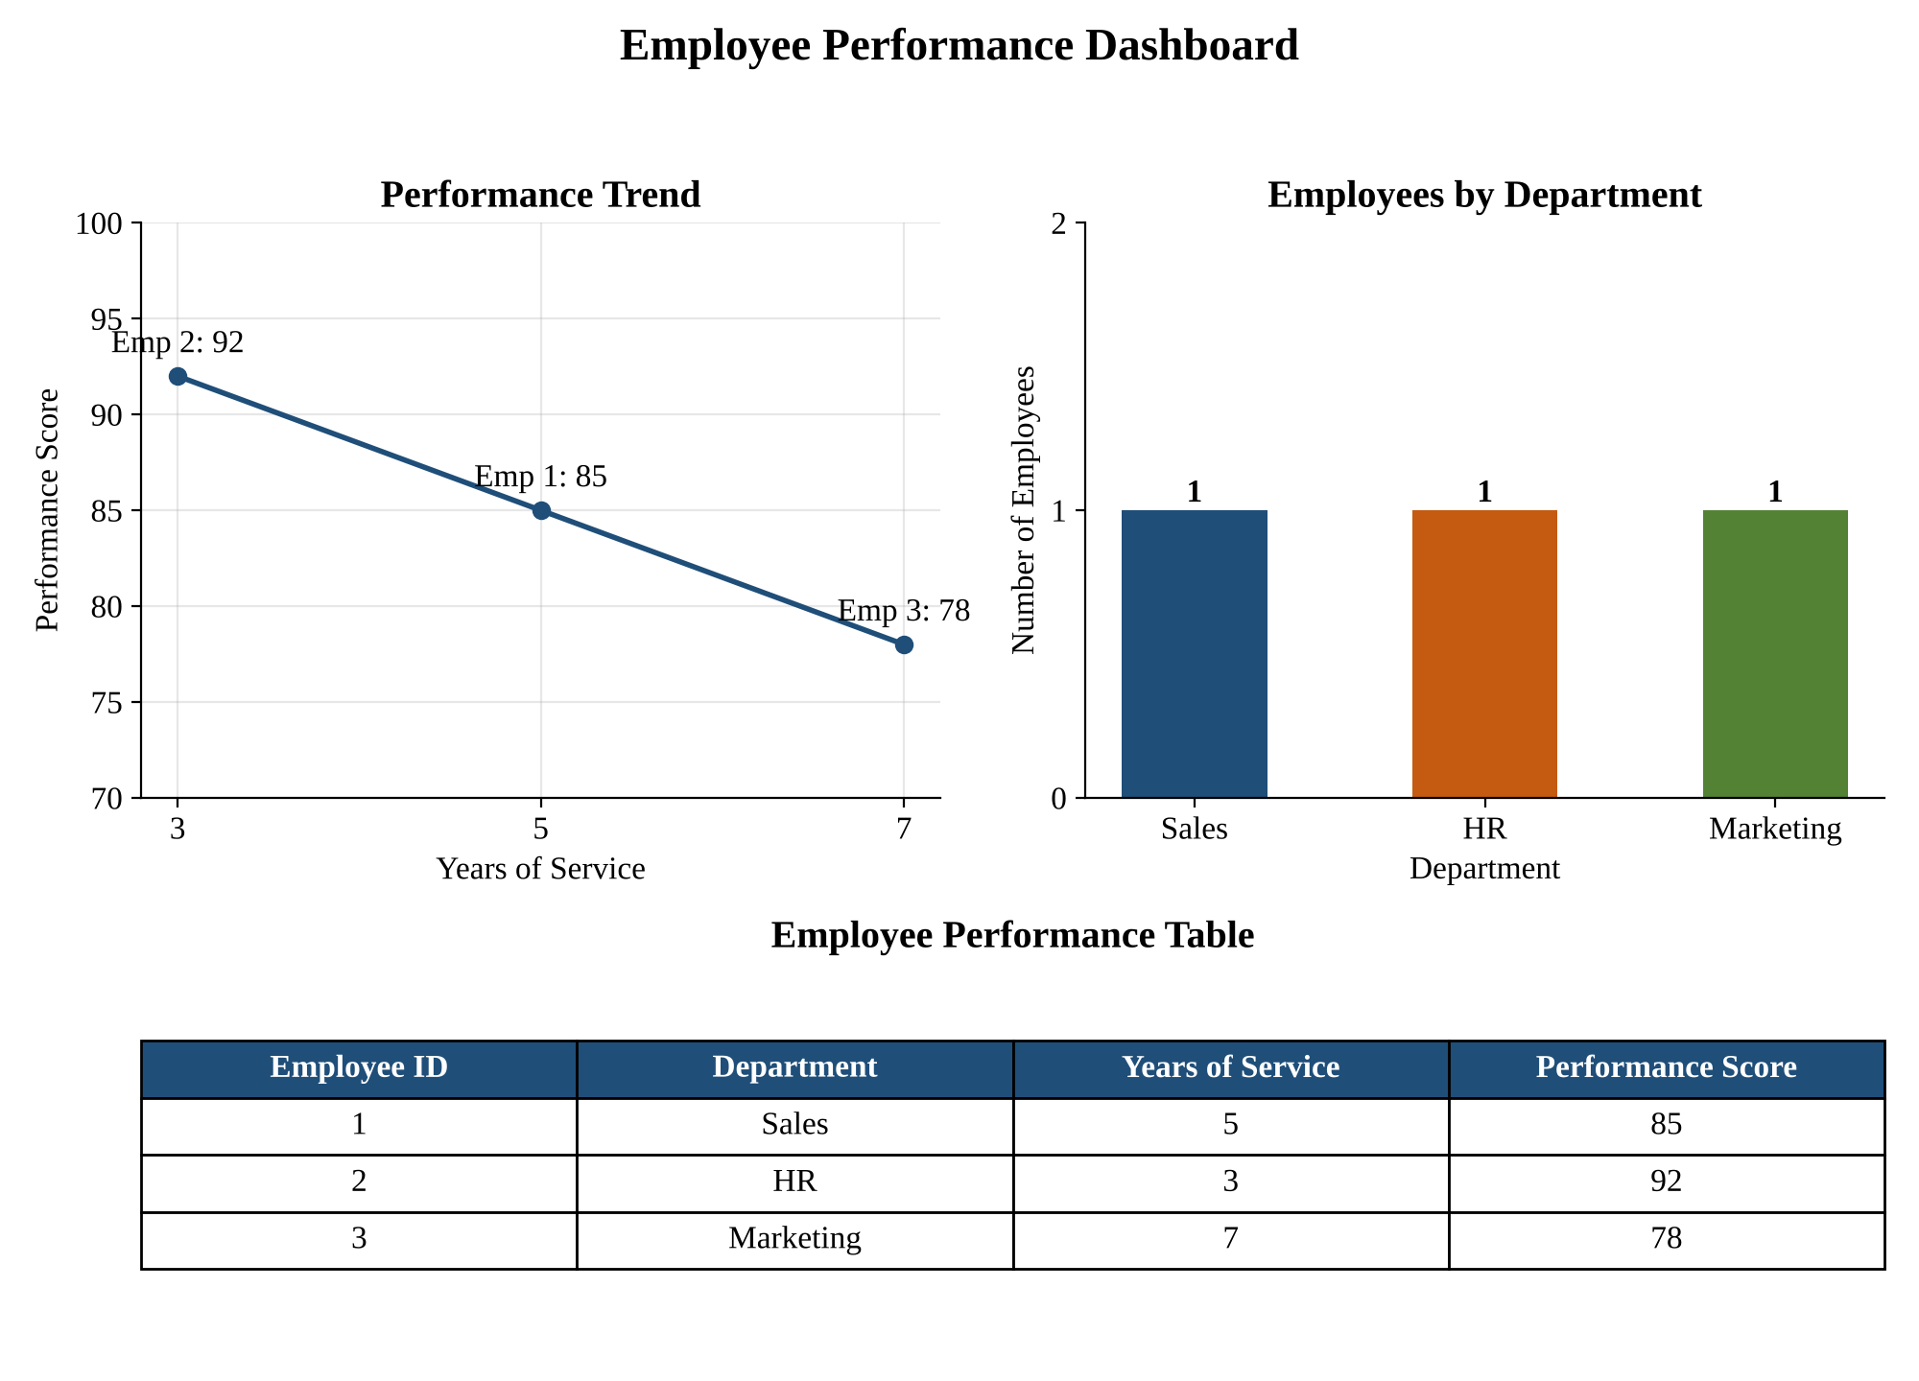
Figure 3: Employee Performance dashboard (line chart, bar chart and table combined)
Steps to build it in Tableau
Step 1. Create three worksheets: Performance Trend, Department Bar Chart and Employee Table (Questions 1–3).
Step 2. Click New Dashboard; set Size to Automatic or Fixed (1000 × 800).
Step 3. Place the line chart and bar chart in the top row and the table in the bottom row.
Step 4. Enable ‘Use as Filter’ on the bar chart and line chart so selecting a department or employee filters the other views and the table.
Step 5. Add a Department filter and a Performance Score range filter applied to all worksheets, then add a title.
Step 6. Save/publish the workbook (Tableau Public or Server).

